During the meeting in Sweden, matters concerning security related to Internet and new media were dealt with. The students' work on internet security was divided into four sub categories. Security for:
- Government and Institutions
- Banks and Payments
- Companies
- Private persons
As a final product, fact sheets for use in schools was created. These fact sheets summarized the findings of the workshop groups
( http://www.sifaplus.eu/en/security/results/item/372-sweden-meeting-student-results-on-internet-security )

C5 C6  Sweden | Sunday 12- Saturday 18 April 2015 | Third pupil exchange in Sweden:  Matters concerning Security on the Internet:  · Spam  · phishing  · pharming  · Viruses and malware  Activities such as: During the meeting in Sweden, matters concerning security related to Internet and new media were dealt with. The students' work on internet security was divided into four sub categories. Security for:  - Government and Institutions  - Banks and Payments  - Companies  - Private persons  As a final product, fact sheets for use in schools was created. These fact sheets summarized the findings of the workshop groups  ( http://www.sifaplus.eu/en/security/results/item/372-sweden-meeting-student-results-on-internet-security )  - Presentations of students and teachers participating in the meeting  - Statistics concerning the matters of the meeting presented by partners  - Discussion comparing the phenomena in the countries of the project  - Discussion concerning policies that could help reduce the problems encountered  - Searching for solutions to reduce the problems (workshop)  - Making decisions about activities following-up the meeting (workshop to prepare material)  - Making decisions about results of the meetings and material posted on the SIFA site  - Activities in order to know the culture of the country where the meeting is held  - Assessment of meeting (questionnaires)

 | APRIL | Group picture in front of the Fridagymnasiet, Vänersborg, Sweden:  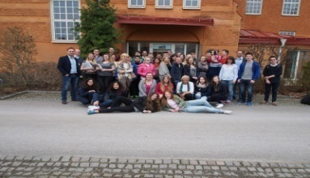  Hosts in Sweden:  Hanna-Klara Arwedal-Petterson, Adam Strandberg-Hasselind  Leon Axwalter, Evelina Pettersson, Karen Nyquist, Josefine Viljakainen  Lovisa Wikmark, Anna Kristiansson, Carl Österbrand, Per Isberg  Linnéa Sundén, Oscar Eriksson, Malin Hoffman, Elin Andersson
 | 12-18 April | Schedule for the meeting taking place in Stockholm and at the Fridagymnasiet in Vänersborg | http://www.sifaplus.eu/en/security/activities/item/285-schedule-for-the-sifa-project-meeting-in-sweden
 | 12 April | Arrival Stockholm, Accommodation at the Af Chapman hostel for Swedish host students and international participants, Presentation of the schedule and activities 12-13 April, Guided sIghtseeing by bus in Stockholm, Dinner together.
 | 13 April | Museum of Technology:  -4D experience: Building beyond limits.  -Lecture and Pedagogical guided tour of the exhibition: Digital revolution about the development of the internet and multimedia  - Changing of the Royal Guards at the Royal Palace  - Walk in groups in the Old Town of Stockholm  - Guided pedagogical tour at the Vasa Museum |  | http://www.tekniskamuseet.se/1/617.html (4D film experience)  http://www.tekniskamuseet.se/1/5673.html (exhibition Digital revolution)  http://www.kungahuset.se/royalcourt/visittheroyalpalaces/theroyalpalace/theroyalguard.4.396160511584257f2180001515.html  http://www.stadsmuseet.stockholm.se/Documents/02%20UTST%C3%84LLNINGAR%20OCH%20VANDRINGAR/Historisk_stadsvandring_genom_Gamla_stan.pdf  http://www.vasamuseet.se/en/
 | 13 April | Teachers - Meeting with Erasmus+ KA 2 program clerk Jessica Hintze at the Swedish NA - UHR i Stockholm.  Discussion about the activities of the SIFA project already carried out and the activities to come as well as news about dissemination and reports for the NA. |  | http://www.sifaplus.eu/en/security/activities/item/267-visiting-swedish-council-for-higher-education
 | 13 April | After the project activities in Stockholm ,students and teachers go together with their Swedish host students by chartered bus to Vänersborg. Cultural activities during the 6 hour bus ride and dinner together. Host family pick up in Vänersborg at 21.30

 | 14 April | - Introduction to the week’s topic and schedule.  - The first task: Individual presentation in the workshop groups  - Introduction to the work leading up to the final product.  - Workshops in four groups  - Introducing the Swedish culture and FIKA  - Lecture: IT security&policy - GKN Aerospace ( Marc-André Haché)  - PE activities - “Boot camp”  - Social and cultural student evening at school, movie: Catfish | http://www.sifaplus.eu/en/security/activities/item/295-sifa-sweden-introduction-to-the-week-s-project-activities  http://www.sifaplus.eu/en/security/activities/item/294-sifa-sweden-individual-presentation-task-tuesday-14-april  http://www.sifaplus.eu/en/security/activities/item/291-group-work-on-internet-security  https://sweden.se/culture-traditions/fika/  http://www.sifaplus.eu/en/security/activities/item/286-lecture-on-industrial-it-security-by-marc-hache  http://www.imdb.com/title/tt1584016/ (film)
 | 14 April | Teachers:  Visit to Frida Utbildning (Education) Head office and an Introduction to the Frida organisation and its schools in West Sweden, the device to educate Backpackers and information about the Frida way of teaching and learning.  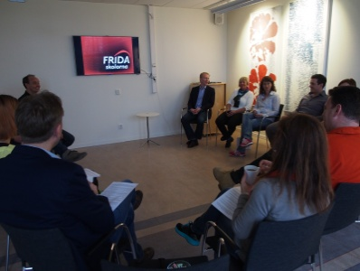 | Greek project coordinator and researcher Dr. Giorgos Errikos Chlapanis made a presentation of the results and analysis of the questionnaires carried out so far. Continued teachers’ planning meeting and discussions about upcoming activities and questionnaires.  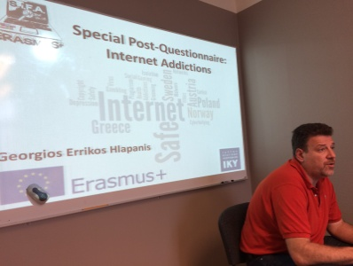
 | 15 April | Innovatum Science Park day:  - Lecture (Pär Mauritzon) - Digital development- Man and Machine  - Using Pixels to build pictures in real life - competition  - Innovatum Science Park introduction (Lillemor Lindberg)  - Internet in China (Holly Xiao)  - Future use of the Internet in our own homes, useful technology for sustainable environment,  - Innovatum’s Incubator projects with young Creative inventors (Elizabeta Veličković) | http://www.innovatum.se/  https://www.facebook.com/Innovatum/photos/pcb.1102253129788355/1102252439788424/?type=1&theater
 | 15 April | Afternoon group workshop activities at school:  - Follow up on the Innovatum Science Park activities about the future of the Internet  - Reflect upon personal internet use according to the diaries the participants filled in before the meeting,  - Discuss the results of the SIFA Project questionnaire before the meeting in Sweden.  - Watch the Buzz Feed video  - Discuss internet privacy and how accessible your personal information is to others  - Continue the group work on the final product. | http://www.sifaplus.eu/en/security/activities/item/293-workshops-on-internet-diaries-and-questionnaire-results-15-16-april

C5 C6  Sweden | Sunday 12- Saturday 18 April 2015 | Third pupil exchange in Sweden:  Matters concerning Security on the Internet:  · Spam  · phishing  · pharming  · Viruses and malware  Activities such as: During the meeting in Sweden, matters concerning security related to Internet and new media were dealt with. The students' work on internet security was divided into four sub categories. Security for:  - Government and Institutions  - Banks and Payments  - Companies  - Private persons  As a final product, fact sheets for use in schools was created. These fact sheets summarized the findings of the workshop groups  ( http://www.sifaplus.eu/en/security/results/item/372-sweden-meeting-student-results-on-internet-security )  - Presentations of students and teachers participating in the meeting  - Statistics concerning the matters of the meeting presented by partners  - Discussion comparing the phenomena in the countries of the project  - Discussion concerning policies that could help reduce the problems encountered  - Searching for solutions to reduce the problems (workshop)  - Making decisions about activities following-up the meeting (workshop to prepare material)  - Making decisions about results of the meetings and material posted on the SIFA site  - Activities in order to know the culture of the country where the meeting is held  - Assessment of meeting (questionnaires)
 | APRIL | Group picture in front of the Fridagymnasiet, Vänersborg, Sweden:  Hosts in Sweden:  Hanna-Klara Arwedal-Petterson, Adam Strandberg-Hasselind  Leon Axwalter, Evelina Pettersson, Karen Nyquist, Josefine Viljakainen  Lovisa Wikmark, Anna Kristiansson, Carl Österbrand, Per Isberg  Linnéa Sundén, Oscar Eriksson, Malin Hoffman, Elin Andersson
 | 12-18 April | Schedule for the meeting taking place in Stockholm and at the Fridagymnasiet in Vänersborg | http://www.sifaplus.eu/en/security/activities/item/285-schedule-for-the-sifa-project-meeting-in-sweden
 | 12 April | Arrival Stockholm, Accommodation at the Af Chapman hostel for Swedish host students and international participants, Presentation of the schedule and activities 12-13 April, Guided sIghtseeing by bus in Stockholm, Dinner together.
 | 13 April | Museum of Technology:  -4D experience: Building beyond limits.  -Lecture and Pedagogical guided tour of the exhibition: Digital revolution about the development of the internet and multimedia  - Changing of the Royal Guards at the Royal Palace  - Walk in groups in the Old Town of Stockholm  - Guided pedagogical tour at the Vasa Museum | http://www.tekniskamuseet.se/1/617.html (4D film experience)  http://www.tekniskamuseet.se/1/5673.html (exhibition Digital revolution)  http://www.kungahuset.se/royalcourt/visittheroyalpalaces/theroyalpalace/theroyalguard.4.396160511584257f2180001515.html  http://www.stadsmuseet.stockholm.se/Documents/02%20UTST%C3%84LLNINGAR%20OCH%20VANDRINGAR/Historisk_stadsvandring_genom_Gamla_stan.pdf  http://www.vasamuseet.se/en/
 | 13 April | Teachers - Meeting with Erasmus+ KA 2 program clerk Jessica Hintze at the Swedish NA - UHR i Stockholm.  Discussion about the activities of the SIFA project already carried out and the activities to come as well as news about dissemination and reports for the NA. | http://www.sifaplus.eu/en/security/activities/item/267-visiting-swedish-council-for-higher-education
 | 13 April | After the project activities in Stockholm ,students and teachers go together with their Swedish host students by chartered bus to Vänersborg. Cultural activities during the 6 hour bus ride and dinner together. Host family pick up in Vänersborg at 21.30
 | 14 April | - Introduction to the week’s topic and schedule.  - The first task: Individual presentation in the workshop groups  - Introduction to the work leading up to the final product.  - Workshops in four groups  - Introducing the Swedish culture and FIKA  - Lecture: IT security&policy - GKN Aerospace ( Marc-André Haché)  - PE activities - “Boot camp”  - Social and cultural student evening at school, movie: Catfish |  | http://www.sifaplus.eu/en/security/activities/item/295-sifa-sweden-introduction-to-the-week-s-project-activities  http://www.sifaplus.eu/en/security/activities/item/294-sifa-sweden-individual-presentation-task-tuesday-14-april  http://www.sifaplus.eu/en/security/activities/item/291-group-work-on-internet-security  https://sweden.se/culture-traditions/fika/  http://www.sifaplus.eu/en/security/activities/item/286-lecture-on-industrial-it-security-by-marc-hache  http://www.imdb.com/title/tt1584016/ (film)
 | 14 April | Teachers:  Visit to Frida Utbildning (Education) Head office and an Introduction to the Frida organisation and its schools in West Sweden, the device to educate Backpackers and information about the Frida way of teaching and learning. |  | Greek project coordinator and researcher Dr. Giorgos Errikos Chlapanis made a presentation of the results and analysis of the questionnaires carried out so far. Continued teachers’ planning meeting and discussions about upcoming activities and questionnaires.
 | 15 April | Innovatum Science Park day:  - Lecture (Pär Mauritzon) - Digital development- Man and Machine  - Using Pixels to build pictures in real life - competition  - Innovatum Science Park introduction (Lillemor Lindberg)  - Internet in China (Holly Xiao)  - Future use of the Internet in our own homes, useful technology for sustainable environment,  - Innovatum’s Incubator projects with young Creative inventors (Elizabeta Veličković) |  | http://www.innovatum.se/  https://www.facebook.com/Innovatum/photos/pcb.1102253129788355/1102252439788424/?type=1&theater
 | 15 April | Afternoon group workshop activities at school:  - Follow up on the Innovatum Science Park activities about the future of the Internet  - Reflect upon personal internet use according to the diaries the participants filled in before the meeting,  - Discuss the results of the SIFA Project questionnaire before the meeting in Sweden.  - Watch the Buzz Feed video  - Discuss internet privacy and how accessible your personal information is to others  - Continue the group work on the final product. |  | http://www.sifaplus.eu/en/security/activities/item/293-workshops-on-internet-diaries-and-questionnaire-results-15-16-april
 | 16 April | - Continued group work to prepare the final product  - Lecture about what it is like to be a student at Fridagymnasiet and ICT (Fridagymnasiet’s head Magnus Wallin and dept. head Mikael Sunnanquist)  - After lunch - walk and talk about the project theme along the lake Vänern and sports activities in international groups.  - Evening in host families |  | 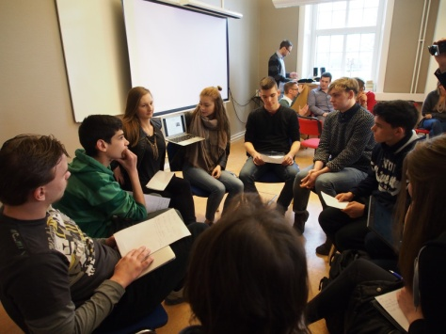
 | 16 April | Teachers: Work session day cont. Preparing paper on research results, New questionnaires, Documentation, Beginning of the project progress report and planning for upcoming activities.
 | 17 April | Group work day! The four international student groups, each working on one Security theme, concluded their work and made presentations of their final product on security for Banks and payments, Governmental institutions, Companies and Private persons.  Evaluation of the project meeting. |  |  | 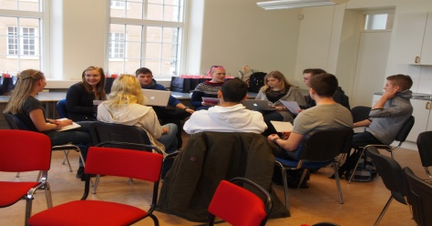
 | 17 April | Teachers:  - Continued work on progress report, questionnaires and activities to be carried out until the next project meeting.  - Visit to the Frida primary school. Welcome by head Lena Lundgren  - Lecture on ICT for the younger pupils and pre-school children by Maria Lundevall (featured in photo) |  |  | 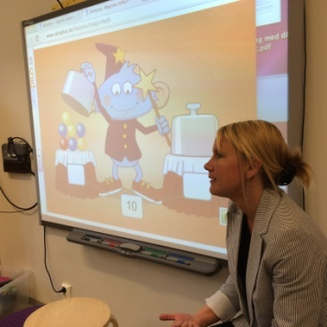
 | 18 April | Departure and evaluation continued.

Samples of the products created during the meeting:

Licence Άδεια
Our SIFA project has officially ended. Yet, we relevant follow up activities will continue for at least two more years and especially dissemination activities for the results and products that have been created. We would like to thank all students, teachers, parents, organisations and scientists/guests that participated in some way and helped us during the project implementation.
The project is now under evaluation by the Greek National Agency and the products presented might be submitted to some change. Yet, meanwhile, we would like to present the Final Products of this 2 year collaboration, for which we are proud of and have been produced by all participants in SIFA. If they are submitted to changes, the current version will be updated by the revised versions.
Anybody can use the material produced during SIFA implementation, as long as they mention the Erasmus+ Project SIFA and that the products have been created by EU Erasmus+ funding.

The attachments (SIFA products) are licensed under a Creative Commons Attribution 4.0 International License and have been created during the implementation of the Erasmus+ Safe Internet For All (2014‐1‐EL01‐KA201‐001294) project.
Τα προϊόντα που ακολουθούν έχουν άδεια Creative Commons Αναφορά Δημιουργού - Παρόμοια Διανομή 4.0 Διεθνές και έχουν δημιουργηθεί στο πλαίσιο του προγράμματος Erasmus+ Safe Internet For All (Ασφαλές Διαδίκτυο για όλους - Σύμπραξη αποκλειστικά μεταξύ σχολείων με κωδικό 2014‐1‐EL01‐KA201‐001294)

