Do you really want to live your life online?
Follow these steps:
- Get an account on every social media you can think of
- Get a lot of friends and followers
- Spend most of your time on these apps or websites to talk to your friends and followers
- Post everything about your life online
- Stop interacting and socializing with your friends and family
- Miss out on sleep, so you can stay on the internet
- Stop focusing on school and your good grades
- Always download the latest apps
If you follow all these steps, you will officially be a real online junkie!
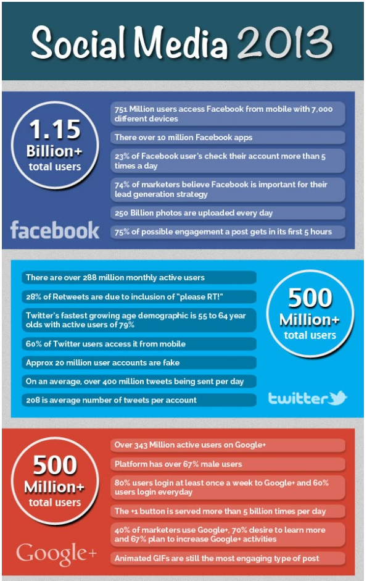

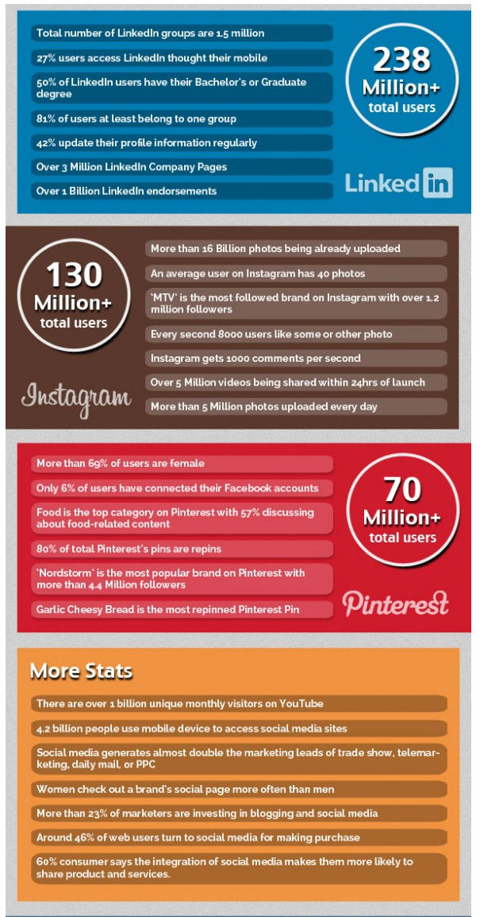

How to get internet addicted in 7 days

Social networks

To get internet addicted is very easy. If you follow these simple rules, you will be addicted by the end of the week; always check Facebook. Check Facebook at work, at school, at home, at birthday parties, at boring conferences, everywhere! You always have time for more internet activities.

Ask yourself these questions after a week:

Do you have a social life besides Facebook?
Do you have anything to do in your spare time?
Do you sleep well?
Do you have potential to be something later in life?
Are you NOT socially retarded?

If any of the questions above apply to you, do not worry. We got the solution.
Firstly, ask yourself: “Am I the right person for this task?” If you figure out you are 100% sure, follow this list:
- Get yourself some beer, whiskey and diapers
- Lock your door and swallow the key
- Destroy your phone by using it as a baseball, before you later bake a cake with the phone inside. If you have a fireplace in your home, make sure to use it as fuel just in case it still works. Flush the rest into the toilet.
- Throw your toilet(s) out the window. You do not have time for toilet when you are addicted. You bought diapers earlier, so you will not need it.
- Download Skype and make a Facebook account, add everyone you see without asking. The more internet friends, the better. Right?
- Start playing Poker and Farmville on Facebook. You can even waste your money there! Awesome? We know.
- Profit.
Now you are on your way to getting addicted. Can you feel the amazing feeling of addictiveness?
No? Then I am sorry, but you have no future, at least not as an internet addict.
FACTS
Facebook, twitter, facebook messenger, snapchat, tumblr, instagram, whatsapp, ask.fm, kik viber
Social Networking Sites are virtual communities where users can create individual public profiles, interact with real-life friends, and meet other people based on shared interests. They are seen as a ‘global consumer phenomenon’ with an exponential rise in usage within the last few years.
What are first signs of addiction?
- Feeling empty, sorrowful and irritable when not using the computer
- Telling lies to family and friends about activities.
- Having problems with school and job
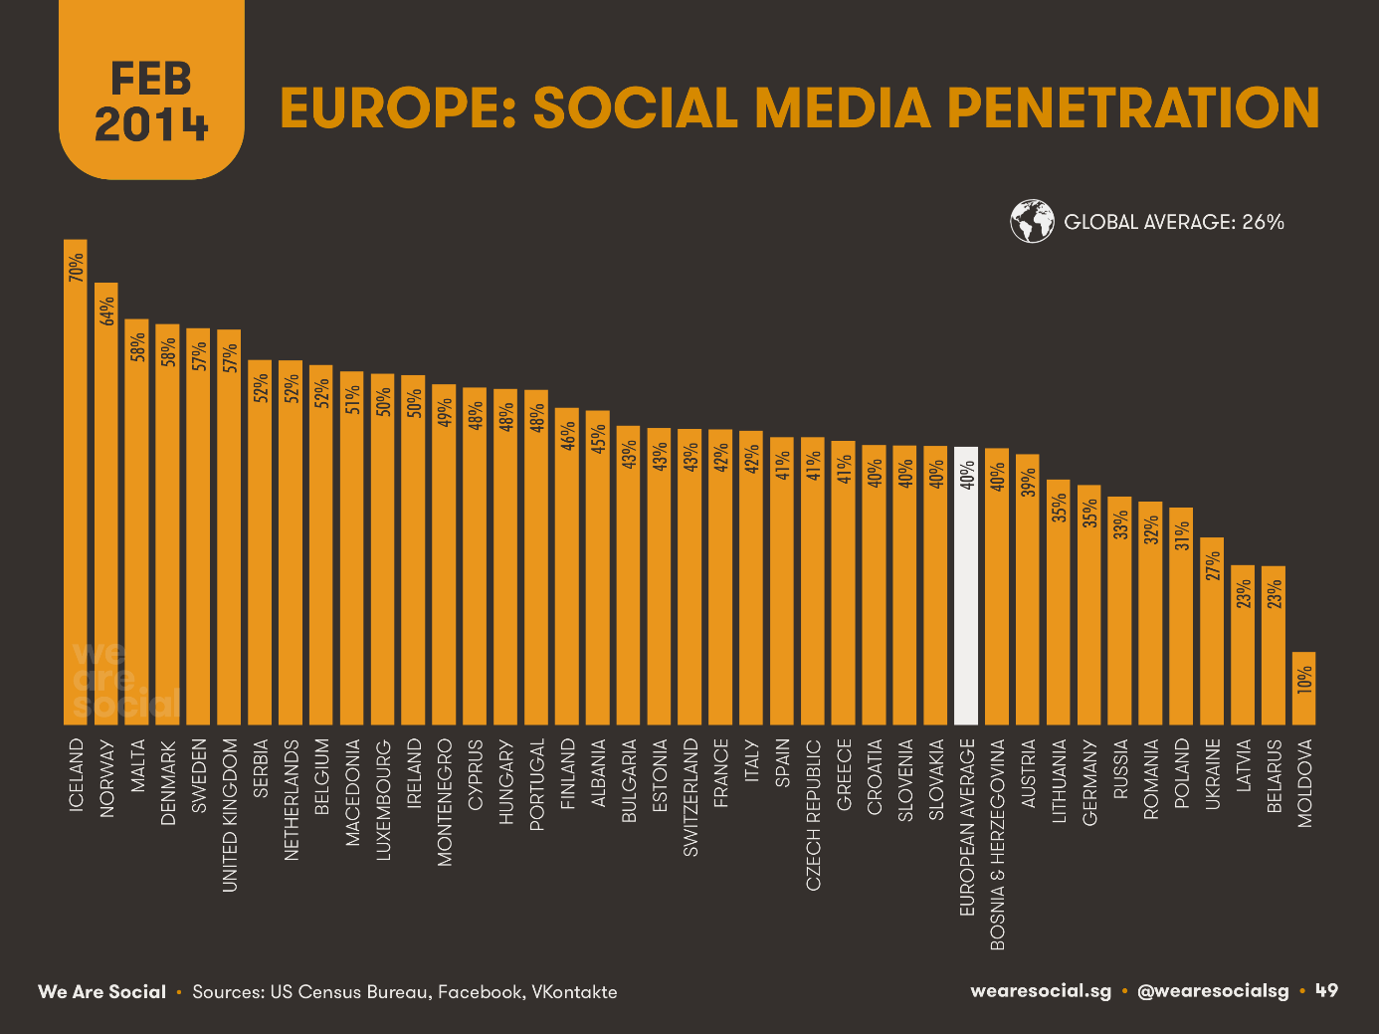

When can you be considered a real online junkie?
- you stay on the internet most of the time
- you stop socializing and interacting with people in real life
- you miss out on sleep to stay online
Classification of social media:
Social-media technologies take on many different forms including magazines, Internet forums, weblogs, social blogs, microblogging, wikis, social networks, podcasts, photographs or pictures, video, rating and social bookmarking. Technologies include blogging, picture-sharing, vlogs, wall-posting, music-sharing, crowdsourcing and voice over IP, to name a few. Social network aggregation can integrate many of the platforms in use.
Global usage:
"The Middle East and North Africa region has one of the most youthful populations in the world, with people under 25 making up between 35-45% of the population in each country. They make up the majority of social media users, including about 17 million Facebook users, 25,000 Twitter accounts and 40,000 active blogs, according to the Arab Advisors Group.

Internet is one of the best inventions in the world. You can communicate with other people from all over the world and you can do this by going on different kind of social media. You can get information from different websites. You can communicate with your friends (for example via WhatsApp, kik, Facebook, twitter, tumblr, …), you can watch videos of other people on Youtube, you can send or post pictures. (Snapchat, instagram, …)

